**Les visiteurs du site de aout 2011 à mars 2012**

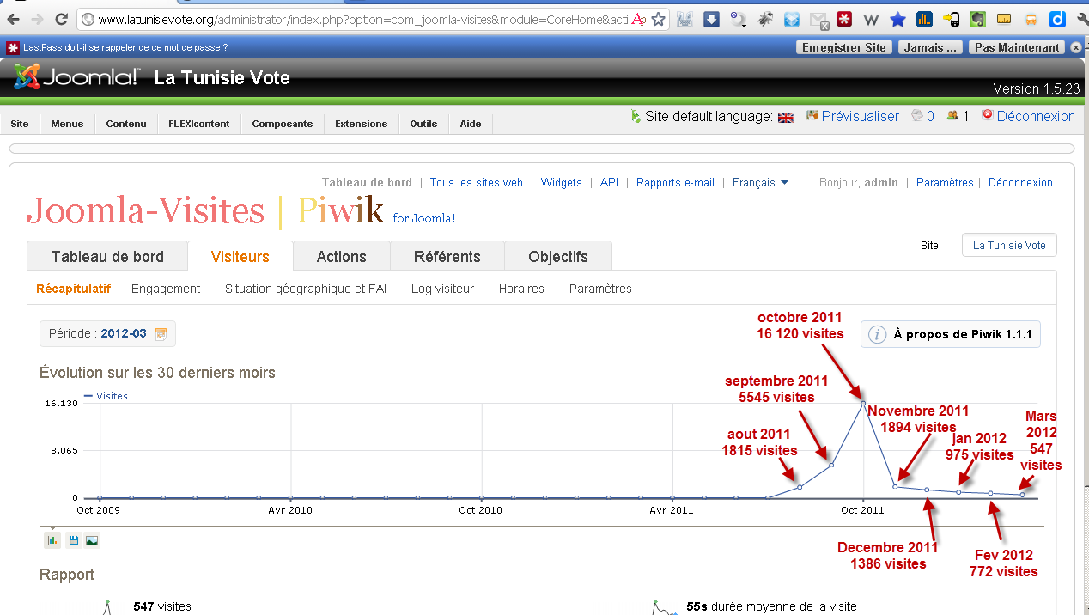

|  |  |  |  |  |  |  |  |  |  |  |
| --- | --- | --- | --- | --- | --- | --- | --- | --- | --- | --- |
| date | bounce_count | max_actions | nb_actions | nb_uniq_visitors | nb_visits | sum_visit_length | bounce_rate | nb_actions_per_visit | avg_time_ on_site | |
| 2011-08 | 1001 | 84 | 5402 | 865 | **1815** | 472413 | 55% | 3 | 260 |  |
| 2011-09 | 3181 | 195 | 11624 | 4369 | **5545** | 842244 | 57% | 2,1 | 152 |  |
| 2011-10 | 9957 | 80 | 29276 | 14071 | **16120** | 1739460 | 62% | 1,8 | 108 |  |
| 2011-11 | 1375 | 37 | 3486 | 1262 | **1894** | 253021 | 73% | 1,8 | 134 |  |
| 2011-12 | 1098 | 107 | 2500 | 1018 | **1386** | 157792 | 79% | 1,8 | 114 |  |
| 2012-01 | 784 | 22 | 1439 | 774 | **975** | 42834 | 80% | 1,5 | 44 |  |
| 2012-02 | 601 | 32 | 1229 | 624 | **772** | 57051 | 78% | 1,6 | 74 |  |
| 2012-03 | 451 | 17 | 792 | 455 | **547** | 30200 | 82% | 1,4 | 55 |  |