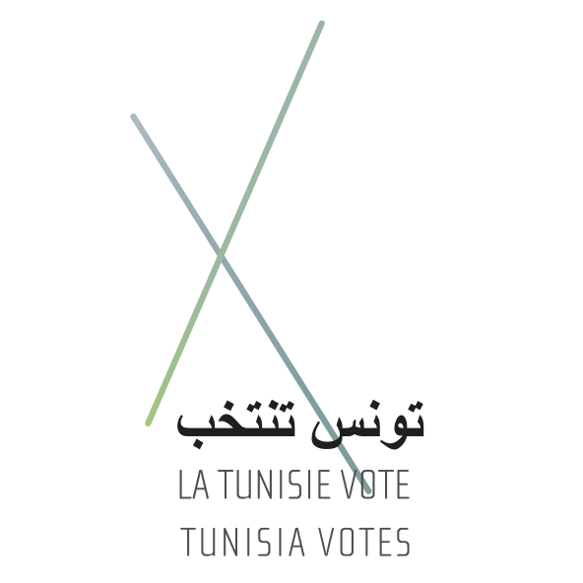**MEDIA ADVISORY**

**LA TUNISIE VOTE**

**Launch event: New project builds journalism in Tunisia**

Tunis, 14 July 2011: *La Tunisie Vote,* a new project that aims to support professional journalism in Tunisia, unveiled their new website at an event held at their offices in central Tunis on Thursday.

The website, www.latunisievote.org, highlights stories by Tunisian journalists writing about the country’s situation post-revolution, including the impact of the revolution on ordinary people’s lives. Stories will be published in the run-up to scheduled elections in October—the first elections since former President Ben Ali fled the country.

“This is a unique initiative, driven by Tunisians themselves who want to share stories from all corners of their country with their fellow Tunisians and with the world at large about how they are dealing with the post-revolutionary situation,” said Nicole Choueiry, *La Tunisie Vote’s* Project Manager.

“Tunisian journalists have a big challenge on their hands right now. They are being asked to rise to the task of creating and working in a free media very suddenly, after years of media repression under the former regime. Also, the public wants to be informed, so that they can make the rights choices in the upcoming elections. They are coping remarkably well with this challenge, and the stories on *La Tunisie Vote’s* websiteis a testament to that.”

The *La Tunisie Vote* project aims to provide professional training to a network of young Tunisian journalists and advance their skills in reporting the reality of their surroundings, under the guidance of a team of Tunisian media experts.

Tunisian youth will be provided with the skills they need to find a job in the burgeoning Tunisian media sector.

*La Tunisie Vote* will also rectify the almost exclusive concentration of media stories on Tunis, by providing unique reporting on the situation in more far-flung regions of the country.

Journalists will be encouraged to use a range of media to produce timely and exclusive material that will be published on the project's website, in Arabic, French and English.

*“La Tunisie Vote* strives to bridge the media gap that exists between the regions and the rest of the country,” said Nicole Choueiry

“It offers Tunisian voters deeper insight into issues that have a direct impact on their lives, while supporting their right to make informed decisions in the upcoming election of a Constituent Assembly, which will write the country's new constitution.”

*La Tunisie Vote* is being implemented by Media in Cooperation – MICT (mict-international.org), in collaboration with the Tunisian Centre for the Freedom of Journalists. *La Tunisie Vote* is being funded by the German Foreign Office.

For more information, please contact

Olfa Moaddeb,

+216 9833 4990

[olfa@mict-international.org](mailto:olfa@mict-international.org)

[www.latunisievote.org](http://www.latunisievote.org)

[www.latunisievote.tn](http://www.latunisievote.tn)

ENDS/